Dear friends and family,

We are members of the Ukrainian scouting organization, Plast. We are holding a hike-a-thon fundraiser on June 2nd at which we will hike the Pacific Crest Trail to Crown Point to a glorious view of Mt. Rainier. We are hiking to raise funds in order to successfully execute a two-week Plast summer camp near Mt. Rainier this summer. Donations received from this fundraiser will also support camp scholarships for our scouts. We are seeking sponsors to support our participation in our fundraiser. Our goal is to raise $10,000 to for the camp.

Thank you very much for considering sponsoring us in this fundraiser. Your donation to Plast Seattle is tax deductible and will truly contribute to ensuring a wonderful Ukrainian summer camp experience for us. Plast offers us an unparalleled opportunity to learn about our Ukrainian heritage, it teaches us how to live in and enjoy the great outdoors, and allows us to build a healthy and fun community. I've attached details about how to donate in support of our upcoming hike-a-thon. Thank you very much for your generosity!

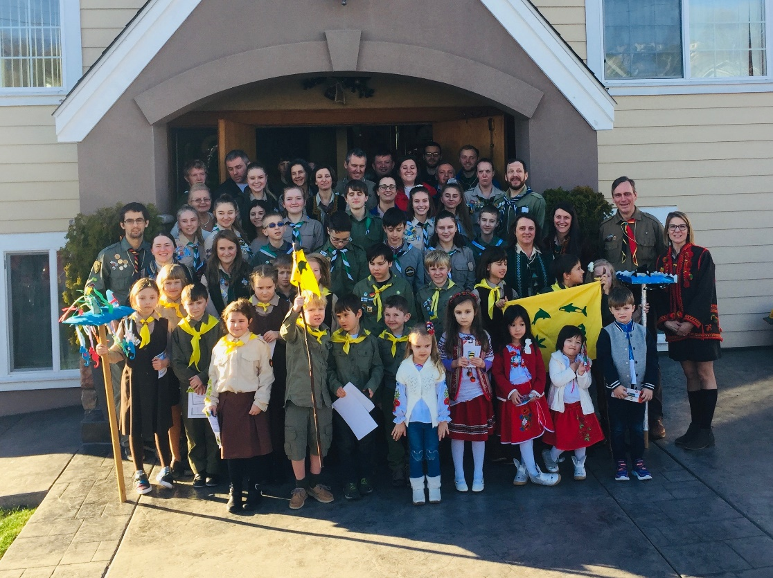

Plast Scouts Seattle, January 2019

